ASAD ULLAH

HSE OFFICER (Nebosh Certified)

Email : asadullahpgsg10@gmail.com Phone No: 0561257678

Objective

I am an enthusiastic and dedicated professional with a motivation to create health and safety environment according to the standard of (H S E). I am able to develop and motivate others to achieve targets under the safe and non- hazardous environment. Adept at professional communication with employees at all levels. Able to function well as a team member or independently.

Professional Summary

I have 04 years’ experience in Health & safety Environment, and I have strong ability to manage projects from conception through to successful completion. A proactive individual with a logical approach to challenges, I perform effectively even within a highly pressurized working environment with a zero LTI (Lost Time Injury) ability to enforce Company EHMS System.

Education Profile

- Intermediate (Pre-Engineering)
- Matric (SSC) in Science Group

Professional Certification

NEBOSH International General Certificated UK. IOSH (MS) International General Certificate UK.

Professional Profile – EPC & Subcontractors Projects

Employer : Abengoa
Project : Independent Water Plant (Rabigh 3)
Client : Acqua Power
Position : HSE Officer
Tenure : January 2021 to May 2022

Employer : Al-Rashid Trading & Contracting Co.
Project : Development of Terminal 1,2,3 and 4 KKIA Project Riyadh
Client : GACA
Position : HSE Officer
Tenure : August 2019 to Dec 2020

Employer : Olympia Chemicals Limited
Position : Safety Officer
Tenure : February 2018 to March 2019

Duties and Responsibilities

  - Daily Inspections of ongoing work activities at Site
  - Conducting Inspections of workplace to identify potential hazards
  - Daily Unsafe Observations and letters given to the concern for rectification
  - Monitoring/ Conduct the Weekly Toolbox Meeting and maintain the record
  - Inspections of Mobile vehicles (Crane, loader, Excavator, Bobcat, Boom lift Etc.)
  - Conducting drills such as Fire drills and Emergency Evacuation drills
  - Report to the Manager regarding any H & S Matters
  - Conducting walk through’ s at project site with all Sub - Contractors and Clients representative and Construction Managers.
  - Attending meetings with Client and discussing the Site Health and Safety reviews and updates
  - Monitoring and conducting the training programs for workers on safety related matters to make sure they are aware of regulations and procedures
  - Preparing the Daily, Weekly and Monthly Safety Reports
  - Investigating the accidents and preparing the accident / incidents reports
  - Inspecting and monitoring work permits and ensure full compliance with requirements.
  - Conducting weekly inspections of power tools and Firefighting Equipment
  - Conducting Monthly Safety Audit of site and preparing site HSE Evaluation (Audit) Report
  - Evaluating hazardous conditions and recommending engineering controls, administrative controls / and or personal protective equipment
  - Ensure that all new employees or operatives working with company received the H&S orientation program
  - Inspect and monitor the place of work, ensuring that all H&S Procedures, Safe
  - working practices are being carried out properly in accordance with relevant H&S legislation and with the requirements of Company
  - Ensure that records or Checklists are completed and filed for inspections, Accidents, Audits and Exercises
  - Promote client health, safety and environment requirement through awareness and

monitor compliance with the said requirements
  - Investigate accident / incident including near misses and determine probable causes and develop appropriates safety measures to prevent recurrence of similar incidents
  - Monitor and ensure good housekeeping practices are maintained
  - Inspection of working on High elevation, fall protection, scaffolding
  - Proper use and maintaining of PPE at Site
  - Prepare and implement barricade and signage wherever required at site
  - Monitor proper supply of drinking water for the work force
  - Checking Housekeeping and tidiness of the toilets
  - Put necessary safety precautions before starting any job
  - Always keep in touch and close with all workers to remind them of safety
  - Inspection of Storage & Handling of Flammable Liquids & Gases, Hazardous Substances, Health.

Computer Skills

    - Windows 10, MS Office 2019 & Microsoft 365.
    - Operating different Special Purpose Software.
    - Software Installation and Trouble Shooting, Excellent Typing Speed.

Personal Details

Iqama Number : 2524028244
Nationality : Pakistani
Present Address : Dammam KSA
Languages Known : English, Urdu, Arabic

References

Will be furnished on demand

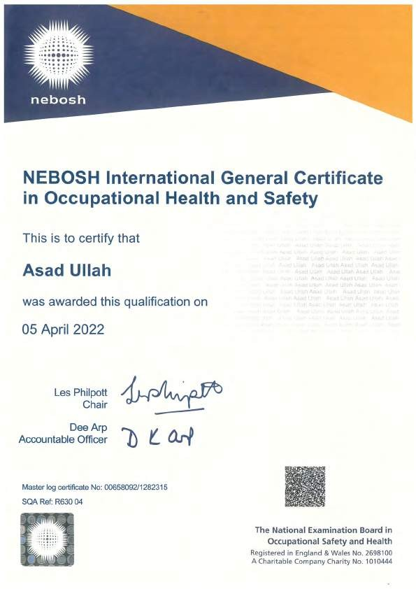

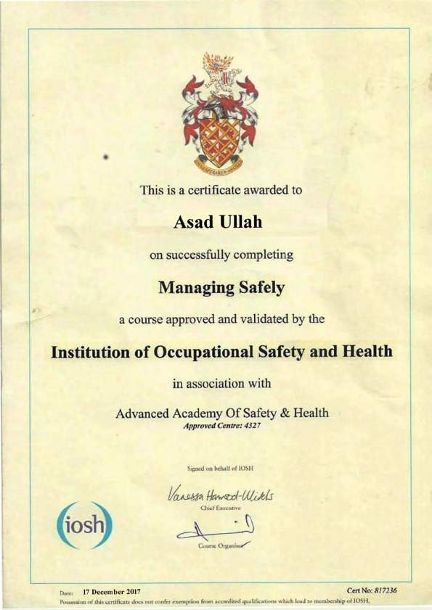

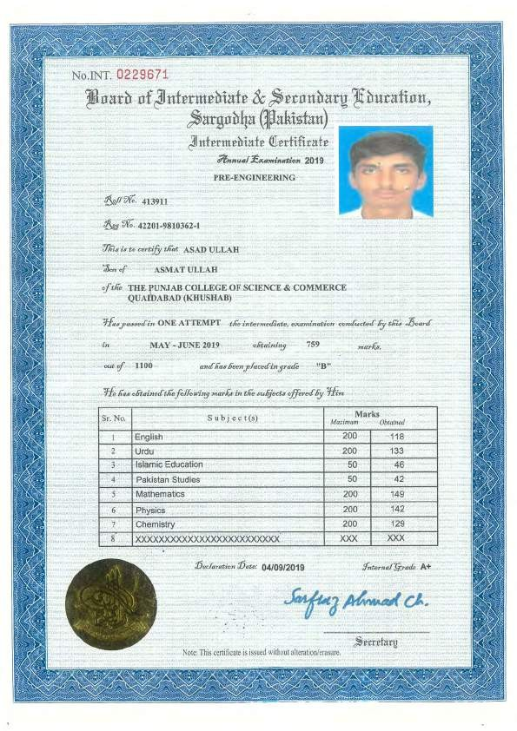

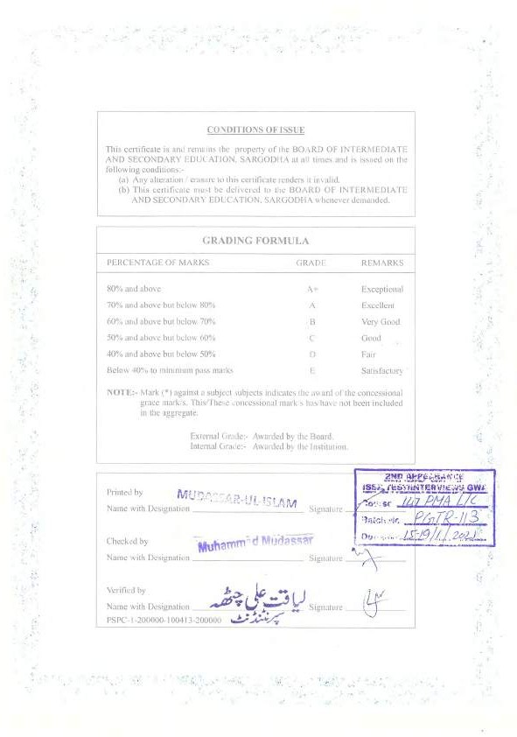

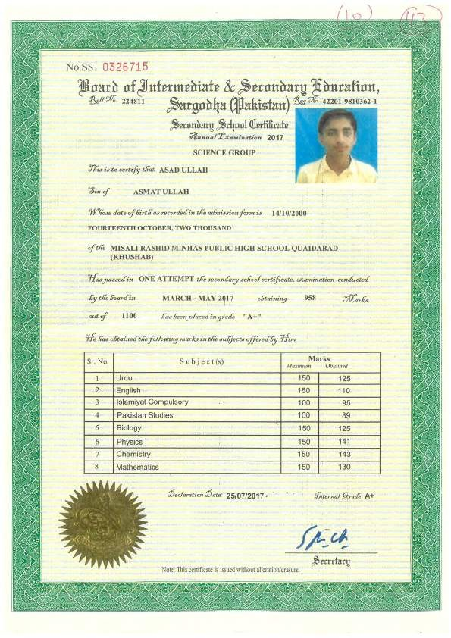

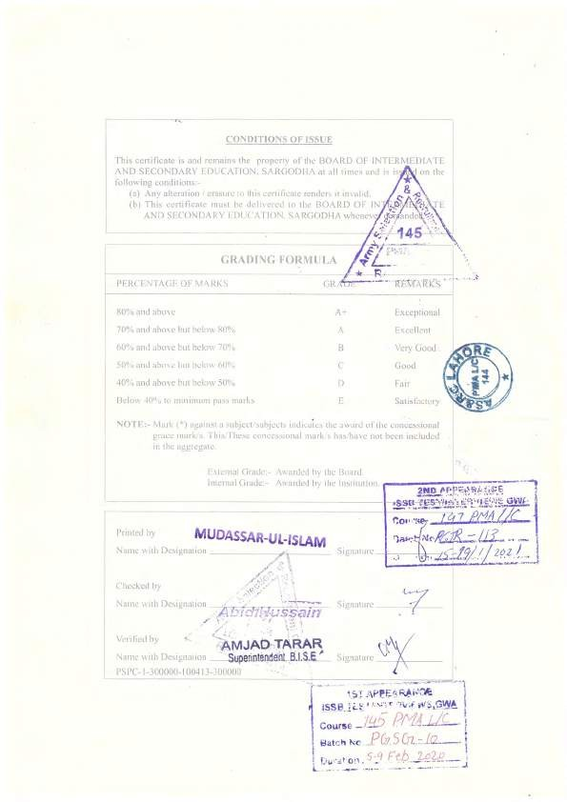

      - 111• TIE.JUN
SIDEM G) VEOLIA
ABENGOA

Rabigh Three IWP

ABENGOA

CERTIFICATE

TO WHOM IT MAY CONCERN

:31.:UW•�t,�__..A
••"tv" ow.. c �,.

This is to Certify that, Mr. ASAD ULLAH was employed in our organization as a
HSE SAFETY OFFICER from January 2021 to May 2022, for Rabigh Three Independent Water Project.

During his stay we observe him obedient, honest and dedicated to his assignment.

This is issued to Mr. ASAD ULLAH for whatever legal purpose may serve him. We thank him for his significant effort carried out during his stay in our project and wish him all

success in future activities.

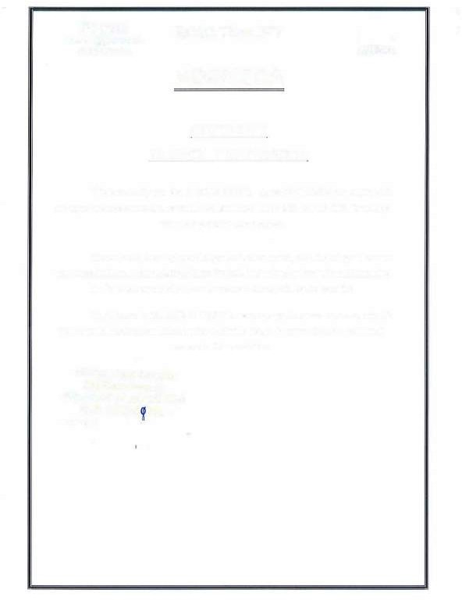

Manager
y,.,, YI- � -..}WI

A:COM

�Y_gLat�a_...,L?--'" �t,.t•as� AL-RASHID TRADING & CONTRACTING CO.
7o 7(/� 'It� �

._t,�l vl;...b.J�JU,"--4-I
Ctf-�rra.! A·�?h01 :, e! (r.1i :. ,,�t�ft
l!GACA

Is hereby granted to Mr. Asad Ullah (Holder ofpassport# NP2743621). He worked here as HSE Safety Officer during the time period of August 2019 to Dec 2020, during his tenture we found him a sincere, honest and responsible employee wtih a professional attitude. He attains excellent skills and greatjob knowledge. His hardworking nature shows his dedication
to his work.

Development of Terminal 1, 2, 3 and 4 at KKIA Project, Riyadh, KSA.

�Mr.A�lex
HSEMa11ager
,,
,...._,..,;
,'�..
,.....,

, •G...- .............-AC·Qol�-
--
\, A..l'COM
...... ... ......

.,
'- Y-D.w;t:l Ozdemir

