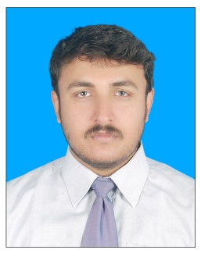
ZUHAIB MUHAMMAD
+92 3349284881
+92 3109278796
Mailing address: House No: 369, Phase-I Ext: Wah Model Town, Wah Cantt. Taxila, Rawalpindi.
Permanent address: POV Dagai,Moh Zanki Khel Teh Razzar Dist Swabi,KpK.
zmk_345@yahoo.com
Objective | To Obtain a challenging position in high quality engineering environment where my resourceful experience and academic skills will add value. To help the organization be more pro-active, productive, effective & improve my professional, personal growth by working collectively & individually.
Professional Experience | Previously have worked in Pakistan Steel Mills as a Management Trainee Officer in HOT STRIP MILL department from August, 2015 to Aug 2017.
Area of Work  Area of Work | - Mechanical Maintenance Work  - Conveyor Roll Table  - Reheating Furnace  - Gas pipeline  - Slab Pusher & Receiver  - EnCo Panel  - Razaque Steel Mill as a Production Engineer (Mechanical) from Sep 2018-Present  - Involved in carrying out schedule maintenance and as well as up gradation of plant.  - Involved in maintenance of reduction and pinion gears, TMT Plant, Pinch Rolls, Mill accessories, furnace and Centrifugal Pumps.  - Efficiently implementing all ISO quality standards, perform audits to verify all manufacturing processes are in compliance with quality control check points and ISO standards.  - Efficiently involved in controlling quality standards as per the requirement of clients.  - Responsible for Planning and development of product rolling as per market demand and schedule sizes as per mill conditions.  - Continuously involved in practices to reduce mill wastages and minimize production cost as much as possible.
Education | WAH ENGINNERING COLLEGE (UNIVERSITY OF WAH), WAH CANTT.  - B.E. IN Mechanical Engineering, October, 2014  Board of Intermediate Education, Peshawar.  - HSSC Examination from Islamia College Peshawar, April, 2010  Pre-Engineering.  Board of Secondary Education, SWABI.  - SSC Examination from Quaid-e-Azam group of School, May, 2009  Science Group.
Final Year Project | - Solar Power Stirling engine Generator
Engineering Software’s | - Pro-E  - Matlab  - Microsoft Office

Personal Information | CNIC: 16202-9340697-9  Marital Status: single  Date of birth: April 01, 1992  Domicile: Swabi (KPK)  PEC Registration #: Mech/28009
References | Available upon request.

