Khuram Ilyas

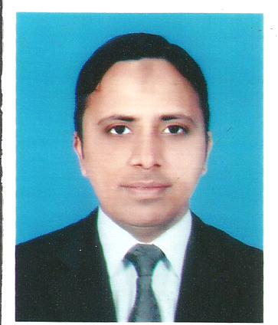
Address: - House No. H- 42, Street No. 90-B,
Haque Street, Gazi Park, New Shad Bagh,Lahore,Pakistan.
Cell: 0301-4176700

Objective:

To enhance my professional achievements with full utilization of my personal, professional and academic capabilities with a vision to provide the best efforts for the organization.

Qualification:

CMA Operational Level 1, 2 and Managerial Level 1
(Completed ) Institution of Cost and Management Accountants of Pakistan.

B-Com (2005) Punjab University, Lahore.
ICS (2003) Board of intermediate and Secondary Education Lahore.
Matriculation (2001) Board of intermediate and Secondary Education Lahore.
(Science)

Computer Skills:

- Installing Windows & other software
- Internet Surfing
- MS office
- Peach Tree
- Office Business Accounting Software

Working Experience:

3 years & above in Accounts Field

Creative Laser Tech:

This company is situated in Lahore. I have worked as Accounts officer in
this company from January 2013 to December 2014.

Responsibilities:

I was performing the following tasks:

1. Generation of Sales and Purchases invoices with proper management of
supporting documents.
2. Update customer outstanding and follow up for recoveries.
3. Managing the company petty cash that use to meet daily bases shorter
expenses.
4. Do payments to the parties by cash or by cheque.
5. Preparation of vouchers like Journal Voucher.
6. Posting these vouchers manually in corresponding Ledger books.
7. Posting these vouchers in to accounting software.
8. Reconciliation of Statements.
9. Filing, documentation and any other work on Ms- Word, Excel, etc. like
Records and Reports.
10. Maintaining minimum level of cost of entertainments and food expenses.
11. Any other work which is related to Accounts according to my job deed.

Oilco Petroleum (Private) Limited:

This is also situated in Gulberg Lahore. I was working in this company as Accounts Executive from November 2015 to April 2016.

Responsibilities:

I was performing the following tasks:

1. Preparation of vouchers like Journal Voucher.
2. Posting these vouchers manually in corresponding Ledger books.
3. Posting these vouchers in to accounting software.
4. Reconciliation of statements.
5. Filing, documentation and any other work on Ms- Word, Excel, etc. like
Records and Reports.
6. Bank dealing.
7. Petty cash management.
8. Any administrative work which is related with Accounts department like
maintenance, etc.
9. Any other work which is related to accounts according to my job deed.

ATS Synthetic (Pvt.) Limited :

This company is situated near Shimla hill, Lahore. I was working in this company as Accounts Executive from October 2016 to September 2017.
Responsibilities:

I was performing the following tasks in this company:
1. Update customer outstanding and follow up for recoveries.
2. Preparation of vouchers like Journal Voucher.
3. Posting these vouchers manually in corresponding Ledger books.
4. Posting these vouchers in to accounting software.
5. Generation of Sales and Purchases Invoices with proper management of
supporting documents.
6. Reconciliation of statements.
7. Filing, documentation and any other work on Ms- Word, Excel, etc. like
Records and Reports.
8. Recording of import entries in to accounting software.
9. Handle insurance Matters
10. Bank dealing.
11 . Any other work which is related to accounts according to my job deed.

Personal Profile:
- Father’s Name : Muhammad Ilyas
- Date of Birth : 31/05/1984
- Religion : Islam
- Marital Status : Single
- CNIC # : 35202-2281764-1
- E-Mail Address : kk20071342@gmail.com
- Skype Name / What’s App : Khuram Ilyas

Activities

- Natt Reading
- Books Reading
- Cricket Playing
- Newspaper Reading
Language Proficiency:

- English
- Urdu
- Punjabi
Reference :
Will be furnished on demand

