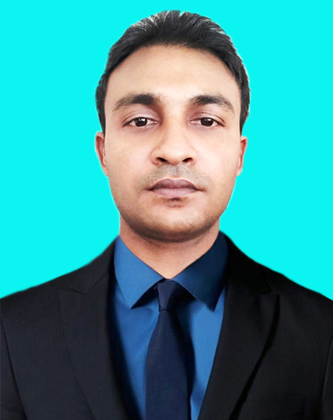

**of**

**CURRICULUM VITAE**

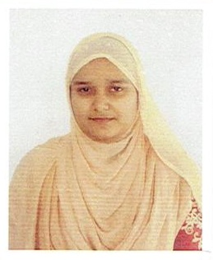

**Profile**

I like to work in a well-reputed organization, be in a competitive and performance based environment to secure a position as a professional expert through competency.

My key qualities:

* Faster learning attitude.
* Hardworking and self–motivated.
* Capable of accepting responsibility.
* Capable of working under stress.
* Possess organizing ability.
* Cross-cultural communication skill.

**MD. ARIFUL ISLAM**

**Cell No. +8801687810295**

**Whatsapp -01687810295**

***E-Mail :*arifkabir0000@gmail.com**

* Listening Music
* Watching Movies
* Traveling
* Reading Books

**HOBBIES**

Known Languages:

English,

Bengali and Hindi.

**INFORMATIONS**

Ms-Word, Excel,Windows 7,10 internet surfing & mailing communication.

**Computer Skills**

Highly recognizedin the community,I canmeet the challengesthat your companywill entrustme. I ama recognized expert inthe field.

**CAREER**

**CONTACT**

**Education :**

**Bachelor Of Science :**

Institute : Islamic International University

Passing Years : 2014

Result : CGPA- 2.92 ( out of 4)

**Diploma inComputer Engineering :**

Institute : Islami Bank Institute of Technology (Framget, Dhaka)

Board : Bangladesh Technical Education Board, Dhaka.

Passing Year : 2011

Result : CGPA-3.20 (out of 4)

**Secondary School Certificate (S.S.C)**

Institute : Daragram M.L High School.

Passing Year : 2005

Board : Dhaka

Group : Science

Result : GPA- 3.75 (out of 5)

**Experience:**

|  |  |  |  |
| --- | --- | --- | --- |
| **Company** | **Designation** | **Duration** | **Place** |
| Global IT | Asst. IT | 1.6 Years | Saver, Dhaka |
| Mahmud Jens Ltd. | IT Executive Officer | 2 Years | Kaliakair, Gazipur |
| BS Asia Ltd. | IT & Admin Officer | 2 Years | Banani, Dkhaka |

**TRAINING & SEMINAR:**

* Internet Application, Microsoft Office (BTEB)
* Cisco Certified Network Administrator (CCNA)
* Android applications and outsourcing.

**I, the undersigned, certify that to the best of my knowledge and belief, these data correctly describe my qualifications and my experience.**

**Date : 18/06/2021**

**Md.Ariful Islam**

**Personal Profile**

* Name  : Md. Ariful Islam
* Father’s Name : Md. Shamsul Alam
* Mother’s Name : Akhi Begum
* Date of Birth : 06/01/1989
* National Id No : 19891705638000044
* Birth Place : Saturia, Manikgonj, Bangladesh
* Gender : Male
* Marital Status : Married
* Nationality :Bangladeshi
* Religion : Islam
* Height : 5’.7’’
* Blood Group: O (+)ve

