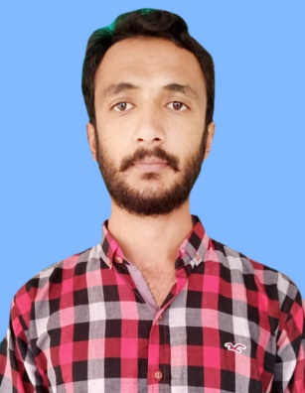 |  | ABOUT IT  I am a dedicated, organized and methodical individual. I have good interpersonal skills, am an excellent team working and am team worker and am very willing to learn and develop new skills. I am reliable and dependable and often seek new responsibilities within a wide range of employment areas. I have an active and dynamic approach to work and getting things done. Seeking to get a career-oriented job in professional environment that offer utilization of my skills.
sibtain abbas  Biomedical Engineer  Postal address:  Mouza Baitwahi Basti miraji wala Teh. jalalpur pir wala Multan, Pakistan  CONTACT  PHONE:  0303-6542785  EMAIL:  sibtainhaiderkanju@gmail.com  PERSONAL INFORMATION:  Father name: Mumtaz Hussain  Date of birth: 15 june 1997  CNIC No: 36301-6786341-7  Marital Status: Single  Domicile: Multan  Religion: Islam  Nationality: Pakistani  LANGUAGE  English  Urdu  Saraiki |  | EDUCATION  - Bachelor's in Biomedical Eng & Tech CGP 3.4  NFC-IET Multan  - Higher Secondary Education (FSC) 2014-2016  - Board of Intermediate & Secondary Education Multan.  - Major subject: Physics, Chemistry, Biology  - Secondary Education (Matric) 2012-2014  - Board of Intermediate & Secondary Education Multan  - Major subject: Physics Math Chemistry Biology  WORK EXPERIENCE  Internship in Biomedical Engineering Dept  Bahawal Victoria Hospital Bahawalpur  10-06-2019 to 10-08-2019  Internship in Eastern Medical Technology Services Lahore  01-04-2021 to 01-07-2021.  Personal Projects  - Digital thermometer  - Temperature and Humidity Sensor  - Design Light Emitting diode  Computer Skills  - MS office  - Word Excel  - Power point  SOFT SKILLS  Good communication skills.  Friendly and open minded.  Good in achieving given tasks.  Intuitive and quick learner.  Strong and affective written and speaking communication.  REFERENCES  - Reference will be provided on demand

