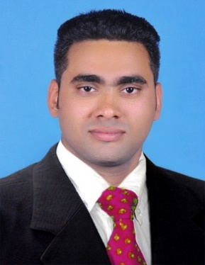

MR. ALWYIN MADACHERIL JOY
Madacheril House,
Chathenkary P.O.,
Thiruvalla, Kerala- 689112.
Mobile No: +918907826501
E-mail Id: alwyinmj@gmail.com

CAREER OBJECTIVE:

Looking for a challenging career which demands the best of my professional ability in terms of technical and analytical skills.
To enhance my working capacities, professional skills, business efficiencies and to serve my organization in best possible way with sheer determination and commitment.
POST APPLIED FOR: SALESMAN
PERSONAL INFORMATION
NAME : ALWYIN MJ
Gender : Male
Date of Birth : 25/03/1990
Father’s Name : Mr. Joy Madacheril
Marital Status : Married
Nationality : INDIAN.
Languages Known : Malayalam, English, Hindi, Tamil and
Arabic
Permanent Address : Madacheril house, Chathenkary P O,
Thiruvalla, Pathanamthitta, Kerala
Pin – 689112
Mobil NO : +918907826501
PASSPORT DETAILS
Passport NO : L5206884
Date of Issue : 07/11/2013
Date of Expiry : 06/11/2023
Place of Issue : Trivandrum

ACADEMIC QULIFICATION:

COURSE | GROUP | INSTITUTION | BOARD | YEAR OF PASSING | MARK (%)
BA | Economics | St. Aloysius College , Edathuva | Mahatma Gandhi University | 2012 | 68
12TH | Science | GOVT .H S School , Thalavady | Kerala State Board | 2009 | 78
10TH | S S L C | SNDP High School  Chathenkary | Kerala State Board | 2007 | 50

WORK EXPERIENCE:

Worked as Sales Executive in GEO AGENCY THIRUVALLA from 01-12-2013 to 23-12-2014
Worked as Salesman in ALMARAI COMPANY ABHA, SAUDI ARABIA from 11-03-2015 to 11-03-2021

CERTIFICATIONS &AFFILIATIONS:

Certificate of Computer Hardware Maintenance & Networking
Certificate of Data Entry Operator
Certificate of NCC B&C level
Certificate of District level chess competition
Certificate of National Seminar on ''Business Ethics''

PROFESSIONAL TRAINING ATTENDED:

Completed 3 Month on the ICDC IT Training program at Trivandrum
Completed 6 months Training program in Computer Operator at Info Park in Kakinada, Cochin

COMPUTER KNOWLEDGE:

Computer Hardware and Networking
MS Office
Windows 8 O S
Photoshop
Typing speed 50 wpm words per minute with 98% accuracy

AREAS OF INTEREST:

Marketing
Coordination.
Driving
Motivation

Skills
Good communication skills.
Can work effectively in a team.
Good budgetary skills.
Self-motivated.
Good and creative problem solving skills.

CONTACT INFORMATION:

Present Address : Madacheril house, Chathenkary P O, Thiruvalla
DECLARATION:

I hereby declare that all the details mentioned above are true to the best of my knowledge and the same can be verified with the concerned authorities. It would be pleasure working in your firm.

Yours faithfully,
Alwyin MJ

