Mohammed Muqtar
Senior Sales Engineer
+91- 7842183360
mohammedmuqtar8@gmail.com
Near AVN College, Dr.no.20-69-2, Asipapa Street, Visakhapatnam - 530001.

Professional Summary

With 7+ Years’ experience in technical sales as Senior Sales Engineer with a demonstrated history and contributed to the 30% growth of revenue for regional building materials and Ready-mix Concrete suppliers over Gulf Region, generating and facilitating long–term contracts with International clients and increasing territory six fold upto $50M. Strong professional with a Bachelor's degree focused in Business Development from AN University.

Education

03/2008 - 03/2012 | Bachelor of Technology  MSSIT COLLEGE OF ENGINEERING  63.00 %
07/2006 - 03/2008 | Intermediate Board of Education  Hindu College  62.80 %
03/2005 - 03/2006 | Matriculation  Universal Public School  63.00 %

Technical Skills

- RFP & RFI Preparation | - Bidding procedures
- Salesforce & Market Intelligence grabber | - Detail oriented data analysis
- Empowers high performing sales teams  - Extensive personal network  - Material application knowledge  - Microsoft Office Expert | - Powerful negotiator  - Relationships builder  - Expertise in troubleshooting [Issues]  - Technical Contracts Preparation

Work Experience

Business Development Analyst
Worktechno Solutions (Construction Division)
02/2020 - ONGOING India
- Develops new key accounts and managing the same to achieve sales targets.
- Preparing techno commercial proposals, RFP, scrutiny and review of contracts/tenders/enquiries and offers.
- Carrying out negotiations and finalizing orders and also ensure timely collection of payments and adherence to payment collection, outstanding systems and procedures as per company policies.
- Prepare narratives related to information contained within the sections of the various reports and respond in a timely manner to queries.
- Quickly understand Company operations and communicate those Operations in a clear and concise manner, acceptable to the Board of Directors and senior management.
- Quickly form rapport and build business partnerships with colleagues outside the Finance Service Line.
- Preparing major Company operations and projects, as well as sales activities, often consulting with subject matter specialists.
- Answered customers' questions and addressed problems and complaints in person and via phone.
- Helped customers select products that best fit their personal needs.
- Educated customers on product and service offerings.
- Kept current on market and product trends to effectively answer customer questions.
- Estimated projects ranging from back yard storage sheds to quarter-million dollar farm buildings.
- Balanced the needs of multiple customers simultaneously in a fast-paced retail environment.
- Marked clearance products with updated price tags.

Senior Sales Engineer
Technimix LLC
08/2017 - 10/2019 Sultanate of Oman
Technimix LLC is the sub-division of leading piling contractor in Oman Technibuild Contracting LLC
- Achieve annual assigned sales targets in the territory/area assigned. Generate new sales/customers & Collect payments within payment period.
- Sales and marketing activities through market research and intelligence reports and keeps management informed by submitting activity and results, monthly reports etc.
- Promote divisional sales products and leading sales team. Meetings with consultants and site contractors for business development.
- Site inspection, safety measures, pours planning & scheduling work as per convenience.
- Receive inquiries/tenders and follow up to ensure deadlines are met. Ensure customer speciﬁcations/requirements are fulﬁlled and documented.
- Prepare Quotation Request Form, review quotations/sales orders for accuracy.
- Interact with other departments to ensure customer requirements are met.
- Attend to and follow up customer complaints to ensure customer satisfaction.
- Input customer information on the CRM system on a daily basis. Project a professional image to potential and existing customers during sales meetings/presentations.
- Ensure the delivery of sold products on time. Identify customer issues/ barriers and participate in sales strategy and development.
- Collect, summarize and analyze customer input and comments. Provide market information to the management (products, prices, competitors, etc. & increase the sales and proﬁtability.

Technical Sales Engineer
Abdur Rahman Ahmed Al-Rajhi Group
03/2013 – 5/2016 Kingdom of Saudi Arabia
Also known as Al-Rajhi pipes is one of the leading wholesaler and contractor in Kingdom of Saudi Arabia.
- Marketing and selling company products and services and enhance the products in front of water EPC contractors in the Kingdom of Saudi Arabia. Estimating the prices and preparing sales quotations, negotiating the offers technically and ﬁnancially to reach to the optimization point with the customer, ﬁnalizing purchase orders, following up the deliveries, and supervise the installation.
- Responsible for managing all indoor/outdoor sales and also site- based activities to ensure that Contracts are delivered on time, to the required standards within budget, whilst maximizing client satisfaction.
- Preparation and administration of subcontracts, task orders, amendments etc.
- Procuring the building materials as per customer requirement and researching for best rates for purchasing the building materials.

Projects Achieved
Role played as Sales Engineer
Technimix LLC
03/2018 - 10/2019 Sultanate of Oman

Project Name : Cotton Yarn Project in Sohar Freezone
Project figure : $300 Million
Description : Played a key role in achieving Ready Mix Concrete supply for the Cotton Yarn Project in Sohar Freezone of Shri Vallabh Pittie Group and the project ﬁgure Four Million OMR.

Role played as Senior Sales Engineer
Technimix LLC
03/2018 - 10/2019 Sultanate of Oman
Project Name : Liwa Cultural Center
Project figure : 1 Million OMR
Description : Achieved a Liwa Cultural Centre Project from client Northline Oasis Trad. & Cont. LLC

Role played as Senior Sales Engineer
Technimix LLC
03/2018 - 10/2019 Sultanate of Oman

Project Name : Liwa Cultural Center
Project figure : 1 Million OMR
Description : Achieved a Ministry project for the supply of RMC to the Construction of 70 Villas in Shinas

Role played as Technical Sales Engineer
Abdur Rahman Ahmed Al-Rajhi Group
03/2013 - 10/2016 Kingdom of Saudi Arabia

• Increasing the yearly Sales from 1.5M to 20M SAR.
• Improving the pricing procedure and adding integrated system for pricing, cost calculation, and proﬁt calculation.

Personnel Details
Name : Mohammed Muqtar
Father Name : Md. Manzoor
Address #20-69-2, Asipapa Street, AVN College, VSP - 530001
Marital Status : Married
Date of Birth : 28-August-1992
Nationality : INDIAN
Religion : Muslim
Height, Weight : 5.5”, 68kgs
Driving Licenses : Saudi, Oman & India
Languages known : Arabic, English, Hindi, Telugu& Urdu

Passport Details
Passport No : K8540276
Place of Issue : Visakhapatnam
Date of Issue : 17/10/2012
Date of Expiry : 16/10/2022

Self-Declaration

I hereby to declare that the above qualiﬁcations & experience of my ﬁtness to undertake an assignment in earnest with ﬂair to communicate effectively (verbal and written) in view of the above, may I request your good self to give a chance to prove my ability for selection and oblige for the same.
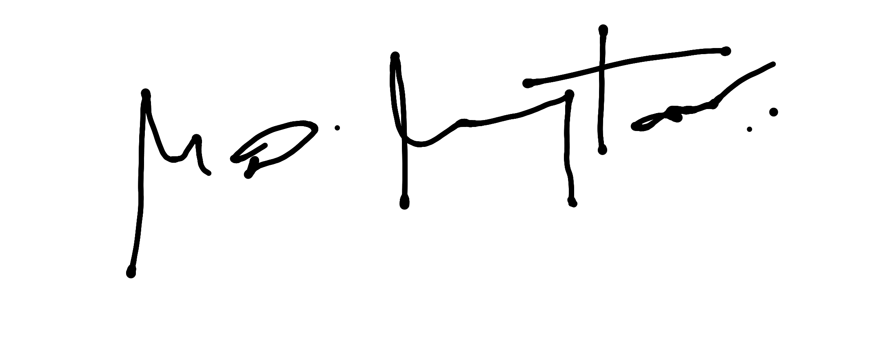
Date: Today
Place: Visakhapatnam

