CURRICULUM VITAE

Name as in passport: | LIJU SHYLAJA SOMAN | 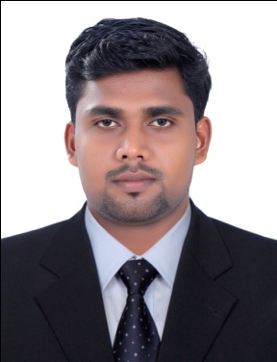
Address: KUNNINAKATHU VAZHAVILA VEEDU KANIYAPURAM PO THIRUVANANTHAPURAM KERALA 695301
Contact Number: 9496327123 8075741101
Email: lichan.007@gmail.com
Educational Qualifications(You may add/delete rows as required)
SL NO | TITLE OF QUALIFICATION | NAME OF QUALIFICATION | NAME & PLACE OF UNIVERSITY/BOARD | YEAR OF PASSING
1 | DIPLOMA | DIPLOMA IN ARCHITECTURE | BOARD OF TECHNICAL EXAMINATIONS KERALA | 2009
2 | DEGREE | B.TECH IN CIVIL ENINEERING | KERALA UNIVERSITY | 2016
3 | PLUS TWO |  | BOARDOF HIGHER SECONDARY EXAMINATION KERALA | 2006
4 | SSLC |  | BOARD OF PUBLIC EXAMINATION KERALA | 2004

Employment/Work Experience(Latest First)(You may add/delete rows as required)
SL NO | DURATION OF EMPLOYMENT |  | NAME & PLACE OF ORGANIZATION | DESIGNATION
 | FROM  (DD/MM/YYYY) | TO  (DD/MM/YYYY)
1 | 08/06/2015 | 31/10/2018 | TAALA BUILDERS AND DEVELOPERS | SITE ENGINEER

Personal details
Aadhaar Number: |  | 6393 9060 7102
Date of birth: |  | 07/07/1988 |  | Gender : |  | MALE
Marital status (Married/Single) |  | MARRIED |  | Religion: |  | HINDU
Passport Details
Passport No: | U8423776 |  | Date of Issue: |  | 09/11/2020
Place of Issue: | TRIVANDRUM |  | Date of Expiry: |  | 08/11/2030

Declaration
I hereby declare that the information given in this document is true and correct.
DATE: 20/07/2021 NAME: LIJU S SOMAN

