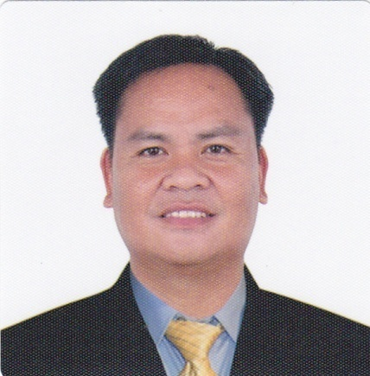
CHARLES D. DE GUZMAN
Address: Lt. Domingo Perez St.,Basista, Pangasinan
Philippines 2422
Email Address: deguzman_charles@yahoo.com
Mobile No.: +63 919 257 0742
KSA Mobile +966 57 298 7128

WORK EXPERIENCE:

Housing Manager/Facilities Manager March 29, 2017 - Present
Saudi Catering & Contracting Company
Project: Saudi Aramco Residential, Haradh Gas Plant,
P.O. Box No.:923 Dhahran - 31311 K.S.A.

Job Summary:
- Inspector Aramco Facilities for Maintenance and cleanliness as per contract between as contractor and Aramco.
- Coordinator for Check in and Check out for Permanent Guest & Transient Guest.
- Coordinator of Maintenance for call center of Aramco maintenance request.
- Conduct cleanliness inspection to improve high standards Housing/Residential Building.
- Conduct safety training for electrical standard that approved by Saudi Aramco Standard.
- Motivate, train and encourage a team of over 100 associates
- Reduce the amount of compensation in the Department by conducting safety trainings and innovated practices
- Work closely with pest control contractor to ensure a pest free environment
- Maintain an accurate inventory while meeting budget area for linen and laundry
- Attend to all guest needs and solve any guest issues
- Conduct training for Room Attendant and Janitor of Hotel standard of cleaning.
- Implement the Contract between Contractor and Aramco.
- SAP Aramco system operating like HMS – Housing Management System

Landscape Maintenance Supervisor, September 24, 2013 – September 10, 2016
Far East Flora Pte.Ltd
555 Thomson Road, Singapore 298140
Tel : +65 6472 5365

- Supervise Nursery Garden Centre for outdoor plants and indoor plants, garden tools and irrigation material selling and project for landscape Construction.
- Familiar of scientific and common name of plants for sale and for landscape project.
- Making quotation for Project and make computation and accounting for profit and loss .
- Communicate well with all team members, managers and clients.
- Track and record all job expenses and hours worked accurately.
- Ensure that all equipment safety and maintenance procedures are followed.
- Supervise landscaper and irrigation technician for proper follow landscape engineer design
- Basic knowledge for Landscape AutoCAD for design garden like interlocking bricks for garden, rooftop Garden and vertical Garden and Indoor Garden and outdoor Garden.
- Familiar of install real grass like Bermuda and planting flowering plants for any season.

Housekeeping Supervisor, October 2010 – October 2012
Holiday Villa & Residence
City Centre Doha, Qatar P. O. Box 47607, Doha Qatar
Tel: +974 408 4888
Website: www.holidayvilla.com

- Inspect all guest room, corridors and service areas and see to it that they are properly cleaned according to the hotel standard.
- Report any damages in the assigned work section and fill out maintenance request form.
- Checks vacant rooms to ensure that they are physically vacant and make necessary report for any discrepancy.
- Checks the room attendant carts to make sure that they are stocked adequately and neatly.
- Check pantry and make sure that they are neat and well supplied.
- Ensure that room attendant/Chambermaid are following the prescribed cleaning procedures of the hotel.
- Check and report all soiled drapes, carpet, furniture and other special housekeeping cleaning needs to his/her superior
- Work with the room attendant/chambermaid in preparation of the room for VIP arrival.

Senior Housekeeper, March 2007 – March 2010
Travelers Inn, Makati Hotel
7880 Makati Avenue Corner, Dapo St, Makati City
Tel: + 632 895-7061

Job Summary:

- Master of bedding, cleaning toilet, rooms as per standard of hotel
- Master of cleaning corridor and using equipment cleaning.
- Inspect VIP rooms & ensure that the room attendant has followed the procedure set.
- Maintain the floor pantry. Check par stock of linen & guest amenities and clean supplies and requisition them in timely manner.
- Prepare the housekeeping report for the front office.
- Conduct for the student training from college school.

Confectionery Industry Worker, March 2003 – February 2006
Melland, Kukje Confectionery Co. Ltd
644-3 Ochang Science Complex, Chunbuk, South Korea
Job Summary:

- Specialize of baking cupcake, cakes and decorating.
- Specialize making candies and chocolates
- Specialize in machine operator and forklift operator
- Chef Baker of pastries and confectionery

Accounting Clerk, July 1999 – January 2003
Amianan Motors Company
Km. 218 National Highway, Rosario, La Union

Job Summary:

- Specialize for vehicle depreciation accounts, registration.
- Specialize for procurement of imported vehicle and spare parts.
- Consignment account and disbursement.
- Analyze discrepancies and unpaid invoice
- General accounting

Education

Degree in Accountancy June 12,1992 – May 31, 2006
Lyceum Northwestern University
Dagupan City, Pangasinan, Philippines

Short Course

Certification: HOUSEKEEPING ROOM ATTENDANT, Awarded: February 2007
(TECP) Training for Excellence Corporation of the Philippines
In partnership w/ Alberta Hotel & Lodging Association (AHLA) Canadian Standard

Address: 7th floor , Erechem Bldg. V. A. Rufino cor. Salcedo Legaspi Village, Makati City

Personal Particular

Age: 46 years old
Birthdate: March 18, 1975
Status: Married
Number of Children: Two
Place of Birth: Basista, Pangasinan, Philippines
Religion: Jehovah’s Witness

