RESUME

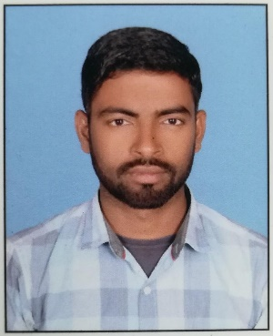
Mohammad Ashif Ali
S/o. Md. Sameer Ansari
Vill +post sisho (west) Sadar mabbi O.P.
DARBHANGA - 846005.
Mobile No. +91 - 7277559376,
E-mail: - mdashifali010@gmail.com

MECHNICAL & ELECTRICAL MAINTENANCE

Introduction
I am a young, ambitious, hard working individual with many years diverse experience in my chosen profession already. I wish to further invest myself in Construction where my natoinal experience and my professional and human qualities will be an incontestable asset for a dynamic.

Qualities:-

Reliable Confident Adaptable
Flexible Determined Resilient

Key Skills:-

- HOUSE & COMMERCIAL ELIECTRICAN

Working Experience

7 year Experiece
03-02-2011 to 10-02-2015 Work in New ashiana builders & Engineers in
Darbhanga as a House Electrician

Education:-

- 10th from Bihar Secondary Examination Board (Patna. Bihar)

Languages:-

Hindi Fluent written & spoken
Urdu Mother Tongue

Passport Details: -

Pass port No. : M 2833615
Date of Issue : 20-10-2014
Date of Expiry : 19-10-2024

Place of Issue : PATNA, INDIA.

Personal : -

Father’s Name: - Mohammad Sameer Ansari
Date of Birth: - 30/03/1992
Nationality: - Indian
Religion: - Islam
Gender: - Male
Marital Status: - Unmarried
Permanent address: - Vill +post sisho (west) Sadar mabbi o.p.
DARBHANGA - 846005.
Mobile No. +91 - 7277559376,

Hobbies & Interests:-

I have visited many countries for both work and recreational purposes. I keep myself very fit with running, weight training & other physical activities. I enjoy music, disining and travelling

Declaration: -

I hereby declare that the above information’s are true, correct to the best of my knowledge and belief.

Date: - …………………….
Place: - ………………………
Mohammad Ashif ali
