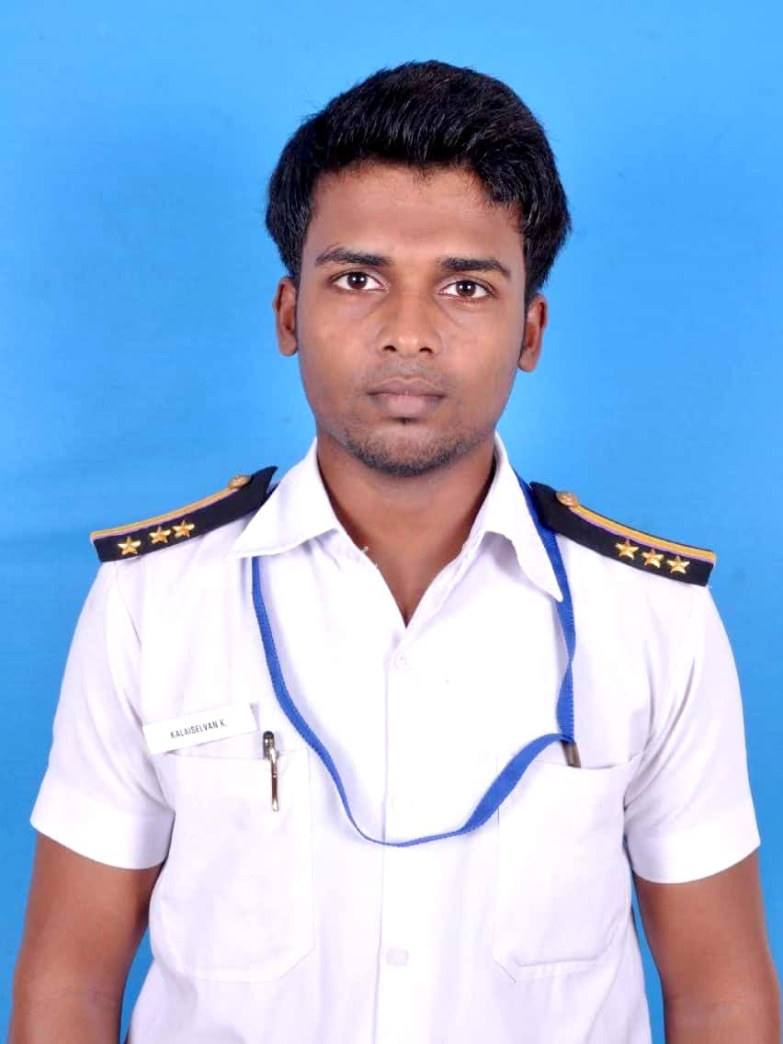
KALAISELVAN KANNAN
kalaikannan1902@gmail.com
+919940931995,
+971527269963

CAREER OBJECTIVE
To seek a challenging position to utilize my skills & abilities in an organization that offers long lasting professional growth while being resourceful, innovative, flexible and committed towards team work

EDUCATIONAL QUALIFICATIONS

Qualification | Board/University | Institution | Percentage
NEBOSH IGC | NEBOSH | National Safety School | 11/12 (overall credit)
B.Tech Marine Engineering | Indian maritime Central university | Indian maritime university, Chennai | 74%
High School | State Board | SSV Sala High School | 72%
S.S.L.C | State board | SSV Sala High SChool | 85%

PRACTICAL TRAINING

- Advanced fire extinguishing and firefighting.
- Medical First aid procedures.
- Safety equipment & procedure.
- Emergency response plan
- Mock drill.
- Safety audit programs

DUTIES &RESPONSIBITIES:

- Working with vessel Captains, ensuring knowledge of Marine procedures and compliance.
- Providing HSE training to the CONTRACTOR workforce, both onshore and offshore.
- Providing proactive input towards safety initiatives.
- Providing Safety Presentations as necessary.
- Producing documents for the sharing of Safety Information, e.g. Safety Flyers.
- Conducting Risk Assessments and Job Safety Analysis as required
- Participating in Incident investigations
- Hazard Recognition: identifying and dealing with hazards
- Risk Management: risk assessment, work permit system, tool box talks, Job Safety Analyses and Marine Risk Assessment and Job Safety Analysis Programs
- Safety training -Marine Training and Safety Drills On-board Marine Vessels
- Safety Communication Plan
- Vessel Inspections
- Demonstrate knowledge in behaviour base safety and conduct training.
- Emergency Response and Incident Reporting Plans and a knowledge of the Marine Departments requirements for incident reporting.
- Safety Equipment and PPE: Demonstrate knowledge with ships LSA, FFA and PPE.
- Accident Investigation
- Familiar with industrial hygiene and occupational health aspects of environmental protection policy

IDENTIFICATION DOCUMENT

TYPE | NUMBER | PLACE OF ISSUE | DATE OF ISSUE
PASSPORT | Z3150898 | CHENNAI | 30/03/2015
CDC | MUM 265674 | MUMBAI | 30/09/2016
INDoS | 15EL0361 | MUMBAI | 20/03/2015

COURSE AND CERTIFICATES DETAILS
CERTIFICATE NAME | CERTIFICATE NUMBER | DATE OF ISSUE | ISSUING AUTHORITY
PSSR | 5454 | 31/03/2016 | INDIAN MARITIME UNIVERSITY, CHENNAI
EFA | 3613 | 31/03/2016 | INDIAN MARITIME UNIVERSITY, CHENNAI
PST | 4176 | 31/03/2016 | INDIAN MARITIME UNIVERSITY, CHENNAI
FPFF | 3644 | 31/03/2016 | INDIAN MARITIME UNIVERSITY, CHENNAI
STSDSD | 572 | 31/03/2016 | INDIAN MARITIME UNIVERSITY, CHENNAI

EXPERIENCE / SERVICE RECORDS

MANORAMA GROUP OF INDUSTRIES, India
Hse Engineer 2021
Sohor Construction RAK UAE
Safety officer dec2019 to 2020
TOTAL CARE MARINE
Marine Engineer cum Safety Officer Sept 2018 to Dec 2019

Westline Shipping management
Trainee Marine Engineer Aug 2017 to July 2018
VESSEL NAME | COMPANY | VESSEL TYPE | RANK SERVED | GRT | SING-ON | SIGN-OFF
HAI PHONG 6 | WESTLING SHIPPING MANAGEMENT | BUlk CARRIER | FIFTH ENGINEER | 14905 | OCTOBER 2017 | JUNE 2018

Shipping Buildin Training:
COMPLETED AFLOAT TRAINING AT KUNJALI MARAKKAR SCHOOL OF MARINE ENGINEERING(KMSMSE), CUSAT
EXTRA CURRICULAR ACTIVITIES AND ACHIEVEMENTS

- Actively participated in various sports activities for inter school.
- Participated in coastal clean-up.
- Participatedin various school karate competitions.
- Participated in District level kabaddi and achieved second prize.
- Achieved second prize in interschool Thirukkural competition.
- Participated in various school and college level events
- Participated in national level intercollege volleyball match

PERSONAL PROFILE

FATHER’S NAME : KANNAN K
MOTHER’S NAME : SIVAKALAI K
PERMANENT ADDRESS : 2/209 EAST STREET VELLALORE (PT), MELUR,
MADURAI, TAMIL NADU, 625109
SEX :MALE
MARTIAL STATUS : SINGLE
DATE OF BIRTH : 19/02/1996
KNOWN LANGUAGES : ENGLISH, HINDI, TELUGU AND TAMIL.
HOBBIES : TRAVELLING, PLAYING VOLLEY BALL, SWIMMING,
EXECISE,POLITICS,.

DECLARATION:

I HERE BY DECLARE THAT ABOVE MENTIONED INFORMATION IS TRUE AS PER MY KNOWLEDGE.

Date: NAME OF CANDIDATE Place: KALAI SELVAN KANNAN

