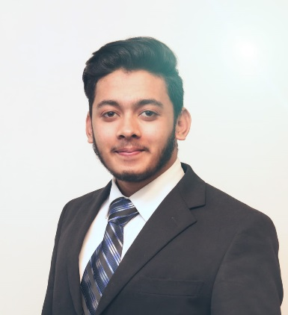
Ghulam Rasool | Curriculum Vitae
9-Gosha Ahbab, Housing Scheme, Ph-iii, Malik Anwar Market, Peco Road, Multan Road, Lahore | 0092-322-4810434 | gr0966677@gmail.com

Objective
To become a part of a dynamic organization where I am able to utilize and enhance my present knowledge and skills.

Skills & Abilities
Microsoft Office
Spoken English
Windows installation
Internet surfing

Experience

Internship

Doctors Hospital

Lahore, Pakistan

May-2016 - October-2016

Assistant Bio Medical Engineer

Eastern Medical Technology Services

Lahore, Pakistan

June-2017 - Currently

Operation and Maintenance services in Radiology Department. New installation of CT scan Machines, Sites renovation, Sites acquisitions, service tenders and overall Reporting
Handling Intensive Care Equipment
Cardiac Monitor, ECG, O.T Light, O.T Table
Suctioin Machine, Defibrilator, Ventilators

Education

Diploma Associate Engineering Bio Medical Engineering

Technology

Punjab Board of Technical Education Lahore

Lahore

2017

Bio Medical Engineer, Over all Grade "B"
BSC Bio Medical Engineering Technology
University of Lahore- continue

Communication
Fluently spoken Punjabi, Urdu, English

