SHAIK MOHAMMED YASEEN 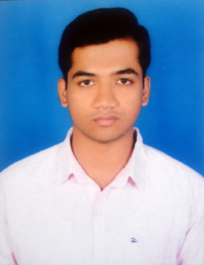

USMAN NAGAR, RAJAMPETA | +91 9701119793 | SHAIKHYASEEN919@GMAIL.COM

# Objective

Seeking employment as an Electrician to use experiences with installing new electrical systems and testing equipment, contribution towards ITC GROUP OF FORTUNE HOTELS.

# Education

## NATIONAL TRADE ELECTRICIAN | JULY 2017 | NOVODAYA INDUSTRIAL TRAINING

* Major:
* Minor:
* Related coursework:

## DIPLOMA INAUTO CAD 2D & 3d (ARCHITECH) | MAY 2016 | AUTODESK CAD CENTER

* Major:
* Minor:
* Related coursework:

# Skills & Abilities

# Experience

## Job Title | Company | Dates From - To

* This is the place for a brief summary of your key responsibilities and most stellar accomplishments.

## Job Title | Company | Dates From - To

* This is the place for a brief summary of your key responsibilities and most stellar accomplishments.